MINI PROJECT

Blinking LED using Arduino UNO

PRESENTED BY:

445 - Iftekhar Ansari

446 - Sunil Gaikwad

452 - Abhay Parocha

455 - Shivam Yadav

**GUIDED BY:**

Mr. Sanjay Deshmukh

DEPARTMENT OF ELECTRONICS TELECOMMUNICATION ENGINEERING YEAR 2021-2022

**Abstract:**

Blinking LED is one of the important projects in alerting someone to indicate the presence of object. But in normal circuit it is difficult to adjust time of turning on and turning of time. Which ultimately lower the chances visibility. But with the help of arduino we can control the timing of light on and off according to our need.

**Introduction:**

the following report in which we have demonstrated how we have implemented blinking LED using Arduino. To blink an LED means we have to turn it **ON**and**OFF** alternatively at a certain interval. So we are going to send commands to turn LED ON and OFF to port 7 of micro controller we have to configure port 7 as OUTPUT in our program. This is achieved inside the void setup () block. Basically this project helps us to indicate the presence of object during night time. Pin modes configuration is used to indicate the pin of the arduino which we are using. We can set whatever time of on and off of the LED as per the requirement and with that single pin of the arduino we can connect as much LED as we want.

**Figure:**

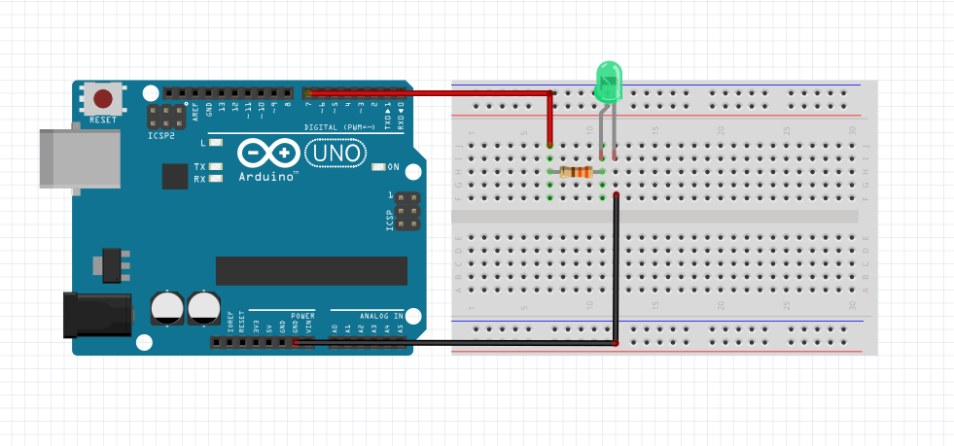

**Circuit Diagram:**

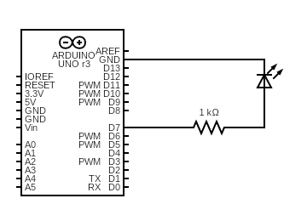

**Code:**

void setup()

{

pinMode(7, OUTPUT);

}

void loop()

{

digitalWrite(7,HIGH);

delay(3000);

digitalWrite(7,LOW);

delay(2000);

}

**Component Used:**

1: Arduino UNO

2: Resistor

3: LED

4: Arduino IDLE software

1. Arduino UNO:

Arduino will help us to give the command for turning ON and OFF of the LED. The program will be stored in this circuit atmega328p. The Digital pin of Arduino will be used to run the program as we are going to mention the pin no of the digital pin. In our program we are giving a delay of 3 sec for LED to turn ON and a delay of 2 sec to turn OFF.

1. Resistors:

over here the resistor will lower the amount of current flow to avoid the damage of the

led. The value of resistor is 1K ohms.

1. LED:

Light Emitting Diode (LED) is used for indication that the light is blinking.

1. Arduino IDLE software:

In this software we are testing the program which is to be run on arduino. This

software will first indicate the error which are there in the program and after that it

will burn the program into arduino with the help of arduino cable.

**LED Blinking Circuits Applications:**

* Dancing LED circuit can be used for any visual sign indication in any highways or it can be used in advertisement hoarding also.
* LED blinking circuit can be used in signaling purpose (It can be used as signal for help, if you are in danger)
* LED blinking circuit can be used as flashing beacon.
* LED blinking circuit can be used as vehicle indicator when it is broke down in the middle of the road. It can be used in operation theaters or offices as an indication that you are engaged in work.
* There are lots of applications with these circuits.

**Conclusion:**

In this paper we have implemented Blinking LED using Arduino in which we have used arduino software and came across many things like the delay must be in millis sec and the burning of program with this offline software.